1. 8-Puzzle Problem
Aim:
To solve the 8-Puzzle Problem using the A* Search Algorithm.
Algorithm:
- Initialize the initial state and goal state.
- Calculate the heuristic (number of misplaced tiles).
- Store the initial state in a priority queue.
- Remove the state with the lowest cost.
- If it is the goal state, display the solution.
- Otherwise, generate all possible moves.
- Add unvisited states to the priority queue.
- Repeat until the goal state is reached.
Pseudocode:
Start
Initialize initial state and goal state
Compute heuristic
Insert initial state into priority queue

While queue is not empty
Remove state with minimum cost
If state is goal
Display solution
Stop
Generate possible moves
Add valid states to queue
End While
Stop
Code:
import heapq

goal = [[1,2,3],
[4,5,6],
[7,8,0]]

moves = [(-1,0),(1,0),(0,-1),(0,1)]

def heuristic(state):
count = 0
for i in range(3):
for j in range(3):
if state[i][j] != 0 and state[i][j] != goal[i][j]:
count += 1
return count

def find_zero(state):
for i in range(3):
for j in range(3):
if state[i][j] == 0:
return i, j

def to_tuple(state):
return tuple(tuple(row) for row in state)

def astar(start):
pq = []
heapq.heappush(pq, (heuristic(start), 0, start))
visited = set()

while pq:
f, g, state = heapq.heappop(pq)

if state == goal:
print("Goal State Reached:")
for row in state:
print(row)
return

visited.add(to_tuple(state))

x, y = find_zero(state)

for dx, dy in moves:
nx, ny = x + dx, y + dy

if 0 <= nx < 3 and 0 <= ny < 3:
new_state = [row[:] for row in state]
new_state[x][y], new_state[nx][ny] = new_state[nx][ny], new_state[x][y]

if to_tuple(new_state) not in visited:
h = heuristic(new_state)
heapq.heappush(pq, (g+h+1, g+1, new_state))

start = [[1,2,3],
[4,0,6],
[7,5,8]]

astar(start)
Output:
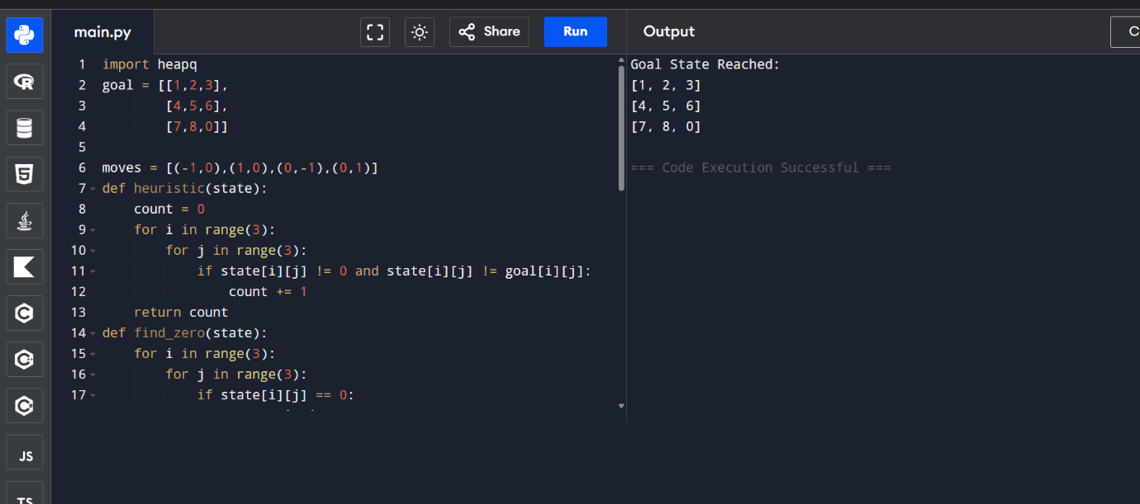

2. 8-Queen Problem
Aim:
To solve the 8-Queen Problem using the Backtracking Algorithm.
Algorithm:
- Start from the first column.
- Check whether a queen can be safely placed.
- If safe, place the queen.
- Recursively place queens in the next column.
- If no safe position exists, backtrack.
- Continue until all eight queens are placed.
Pseudocode:
Start
Place queen in first column

For each row
If position is safe
Place queen
Recur for next column
If solution found
Return
Remove queen (Backtrack)

Display solution
Stop

Code:
N = 8

board = [[0] * N for _ in range(N)]

def is_safe(row, col):

for i in range(col):
if board[row][i] == 1:
return False

i, j = row, col
while i >= 0 and j >= 0:
if board[i][j] == 1:
return False
i -= 1
j -= 1

i, j = row, col
while i < N and j >= 0:
if board[i][j] == 1:
return False
i += 1
j -= 1

return True

def solve(col):

if col == N:
return True

for row in range(N):

if is_safe(row, col):
board[row][col] = 1

if solve(col + 1):
return True

board[row][col] = 0

return False

if solve(0):
print("Solution:")
for row in board:
print(row)
else:
print("No Solution")
Output:
